Type of Article (Size 10)

Instructions to Authors Preparing their Research Articles, Original Articles, and Short Communications for Global Conferences for A4 Page Size (Font Size 20)

First Author¹, Second Author², Third Author³ (Size 10 Bold) No abbreviations allowed
¹Department, University or College Name, State, Country Name. (Size 9 &Italic)

Abstract: (Size 10 Italic)This research investigates the performance enhancement of wireless sensor networks using an adaptive energy-aware routing protocol. The study presents a new hybrid algorithm combining clustering and dynamic path selection for energy optimization. Simulation results demonstrate a 25% increase in network lifetime and 18% reduction in packet loss compared to conventional routing methods. The proposed method is particularly relevant for large-scale Internet of Things (IoT) deployments, offering significant improvements in energy efficiency and network reliability. The findings have implications for designing next-generation IoT communication systems. (Max 250 words, no references, no figures/tables.)

Keywords: (Size 10 & Italic) Energy-aware routing, Hybrid algorithm, IoT networks, Network lifetime, Wireless sensor networks

I. INTRODUCTION (SIZE 12 & BOLD)
Wireless Sensor Networks (WSNs) are a critical component of the Internet of Things (IoT). Efficient energy management is essential for prolonging network lifetime. Traditional routing algorithms often result in early node failure due to uneven energy consumption. This study introduces an adaptive energy-aware routing protocol that dynamically selects cluster heads based on residual energy and communication distance. The proposed protocol aims to balance energy consumption across the network, ensuring more uniform node longevity.

2. FIRST-ORDER HEADING (SIZE 12 &BOLD)
1.1. SECOND-ORDER HEADING (SIZE 10 & BOLD & ITALIC, LEFT ALIGNMENT)
1.1.1. THIRD-ORDER HEADING (SIZE 10 & ITALIC, LEFT ALIGNMENT)
1.1.1.1. FOURTH-ORDER HEADING (SIZE 10 LEFT ALIGNMENT)
Before formatting, save content as a separate text file. Use single returns, avoid hard tabs, and define abbreviations on first use.

3. MATERIALS AND METHODS (SIZE 12 &BOLD)
The materials and techniques section should include enough information to allow all operations to be replicated. If numerous procedures are presented, it may be separated into heading subsections.

Table 1: Comparison of Costing and Cost Accounting (Size 10 Bold)
Basic of Distinction | Costing (Size 10 Bold) | Cost Accounting
Nature | Technique of ascertaining costs. | Special branch of accounting.
Scope | Includes principles and rules for determining product cost. | Classification, accumulation, assignment, and control of costs.
Process | Historical/conventional/standard costing. (Size 9) | Budget establishment, recording, and allocation of costs.

4. RESULTS AND DISCUSSION (Size 12 Bold)
4.1. PERFORMANCE METRICS (SIZE 10 BOLD ITALIC)
Simulation results show that the proposed algorithm improves network lifetime and reduces energy consumption across nodes. Figures 1–3 illustrate the comparative analysis.

4.2. SOME COMMON MISTAKES (SIZE 10 BOLD ITALIC)
- “Data” is plural.
- Subscript for μ0 and other constants must be correct.
- Follow American English punctuation rules.

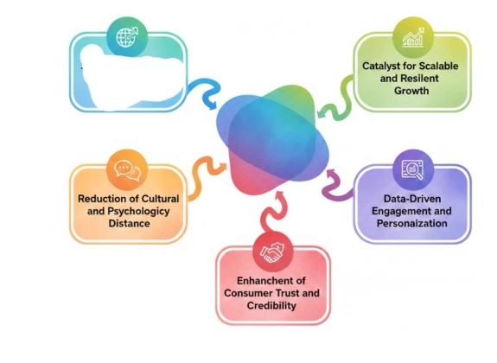
Figure 1.Data Driven Engagement and Personalization (Size 10 Bold)

5. CONCLUSION (Size 12 Bold)
The proposed adaptive energy-aware routing protocol effectively balances energy consumption in WSNs, resulting in increased network lifetime and reliability. This method is highly applicable to large-scale IoT deployments. (Size 10)

6. CONFLICTS OF INTEREST (Size 12 Bold)
The authors declare that there is no conflict of interest regarding the publishing of this paper.

7. ACKNOWLEDGEMENTS (Size 12 Bold)
The authors acknowledge the support of XYZ University and ABC Institute of Technology in providing simulation resources. (Size 10)

REFERENCES (Size 12 Bold)
- G. Eason, B. Noble, I. N. Sneddon, “On certain integrals of Lipschitz-Hankel type involving products of Bessel functions,” Phil. Trans. Roy. Soc. London, vol. A247, pp. 529–551, 1955. [Link]
- J. Clerk Maxwell, A Treatise on Electricity and Magnetism, 3rd ed., vol. 2. Oxford: Clarendon, 1892. [Link]
- D. P. Kingma, M. Welling, “Auto-encoding variational Bayes,” arXiv:1312.6114, 2013. [Online]. Available: https://arxiv.org/abs/1312.6114
- S. Liu, “Wi-Fi Energy Detection Testbed (12MTC),” GitHub repository, 2023. [Online]. Available: https://github.com/liustone99/Wi-Fi-Energy-Detection-Testbed-12MTC

